Computer Graphics Panning

The process of panning acts as a qualifier to the zooming transformation. This step moves the scaled up portion of the image to the center of the screen and depending on the scale factor, fill up the entire screen.

Advantage:

Effective increase in zoom area in all four direction even if the selected image portion (for zooming) is close to the screen boundary.

Inking:

If we sample the position of a graphical input device at regular intervals and display a dot at each sampled position, a trial will be displayed of the movement of the device.This technique which closely simulates the effect of drawing on paper is called Inking.

For many years the primary use of inking has been in conjunction with online character-recognition programs.

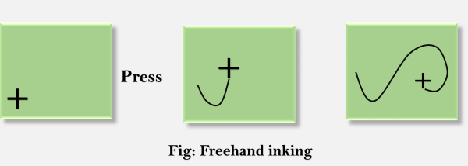

Scissoring:

In computer graphics, the deleting of any parts of an image which falls outside of a window that has been sized and laid the original vision ever. It is also called the clipping.